* **Customer’s Report**

1. **Click Menu**
2. **Click Reports**
3. **Click Customer’s Report**

Menu

Customer’s Report

Reports

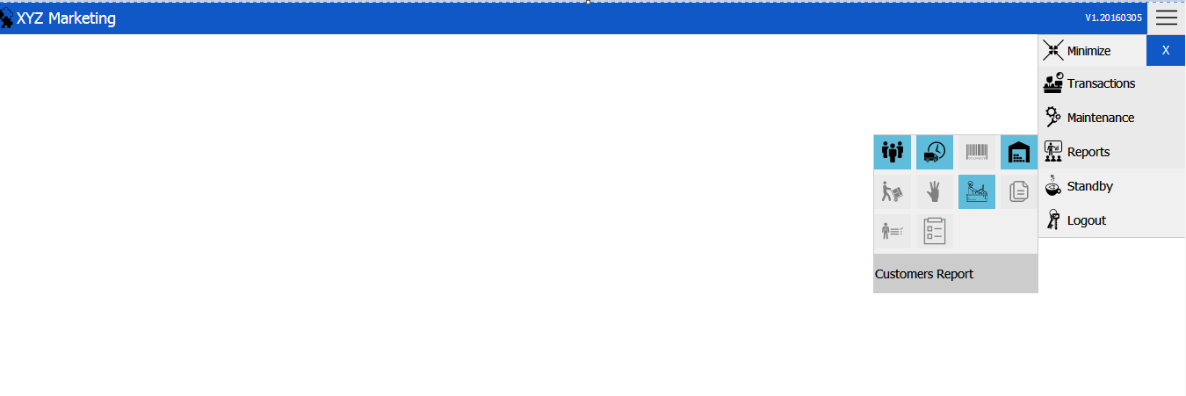

* **New Customer’s Report Transaction**
* **Customer’s Tab**

Customer’s Search Filter Tab

Customers Tab

Status

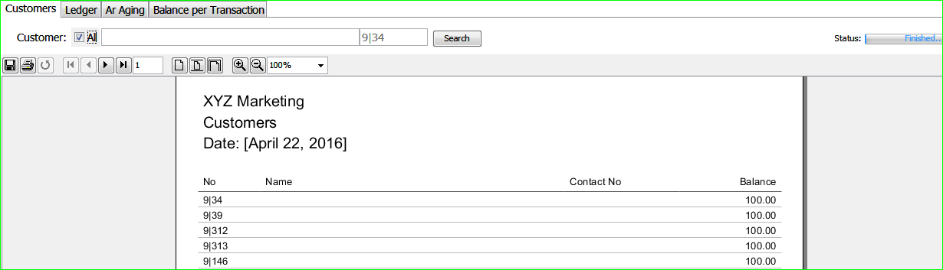

Information Display

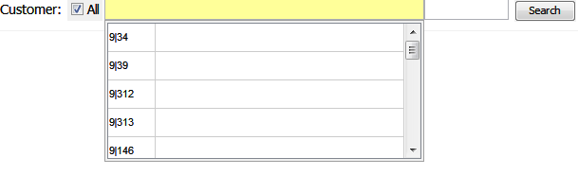

If you want to view all customers, you can just check the check box button “All’’. Or if you just want to search one customer, you can just specify it by typing the name on the search tab.

* **Ledger Tab**

This tab shows the amount paid and the remaining balance of the customer.

Customer’s Search Tab

Ledger Tab

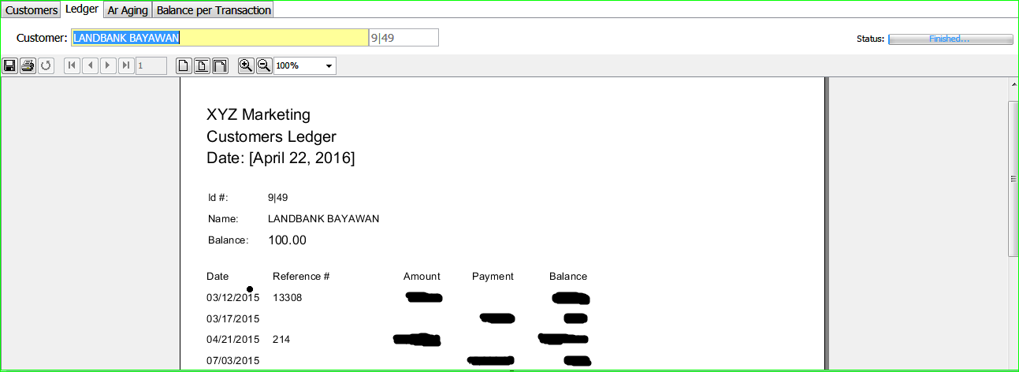

Information Display

* **AR Aging**

Number of days Payable

Customer’s Search Filter Tab

AR Aging Tab

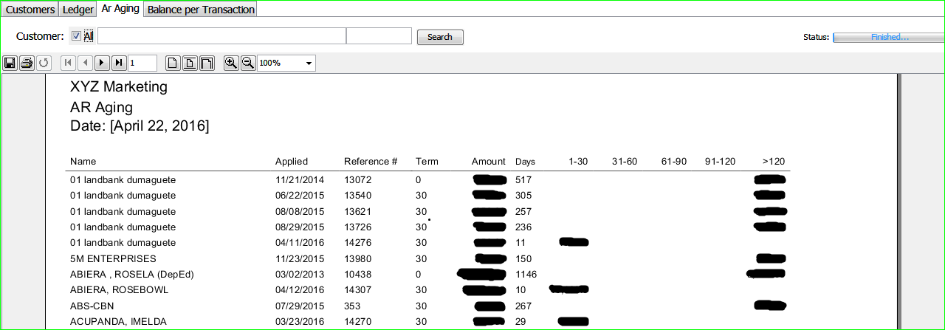

Name of the Customer

Date Applied

Amount Applied

Reference Number

* **Balance per Transaction Tab**

This tab shows the services rendered and the amount for the service.

Customer’s Search Filter Tab

Balance per Transaction Tab

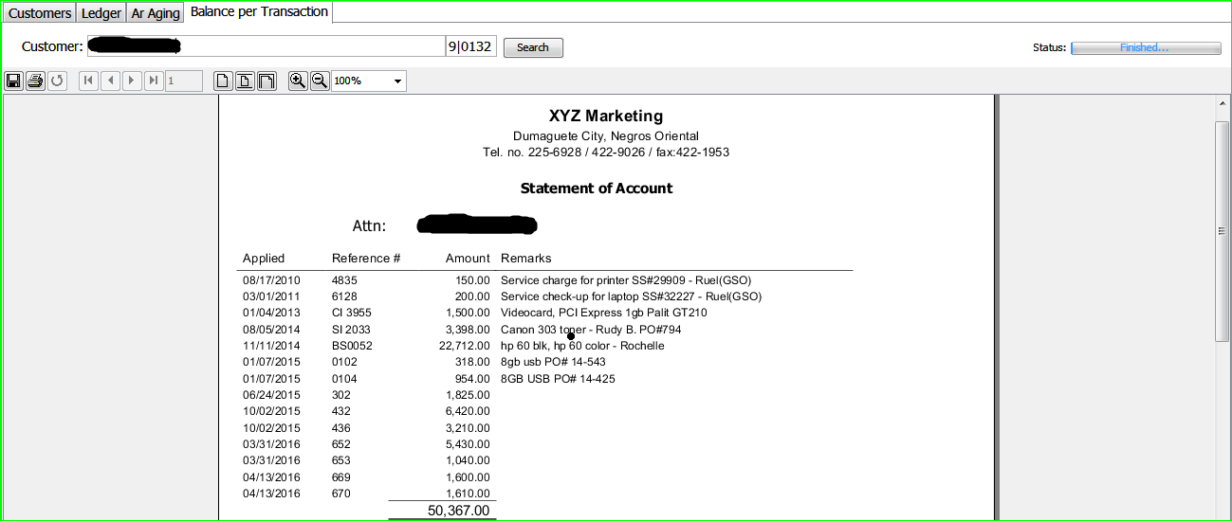

Information Display